附件
潜山市立医院特殊服装服装统计表
科室 | 男医 |  |  |  |  | 女医 |  |  |  |  | 护理 |  |  |  |  | 合计
科室 | S | M | L | XL | XXL | S | M | L | XL | XXL | S | M | L | XL | XXL | 合计
供应室 |  |  |  |  |  |  |  |  |  |  |  |  |  |  |  | 9
介入科 |  |  |  |  |  |  |  |  |  |  |  |  |  |  |  | 1
手术室 |  |  |  |  |  |  |  |  |  |  |  |  |  |  |  | 13
麻醉科 |  |  |  |  |  |  |  |  |  |  |  |  |  |  |  | 12
重症医学 |  |  |  |  |  |  |  |  |  |  |  |  |  |  |  | 21
口腔科 |  |  |  |  |  |  |  |  |  |  |  |  |  |  |  | 5
儿科 |  |  |  |  |  |  |  |  |  |  |  |  |  |  |  | 30
血透室 |  |  |  |  |  |  |  |  |  |  |  |  |  |  |  | 13
急诊科 |  |  |  |  |  |  |  |  |  |  |  |  |  |  |  | 38
产房 |  |  |  |  |  |  |  |  |  |  |  |  |  |  |  | 7
合计 |  |  |  |  |  |  |  |  |  |  |  |  |  |  |  | 149

潜山市立医院各科室工作服装统计表（除特殊科室以外）
科室 | 男医 |  |  |  |  | 女医 |  |  |  |  | 护理 |  |  |  |  | 合计
科室 | S | M | L | XL | XXL | S | M | L | XL | XXL | S | M | L | XL | XXL | 合计
院领导 |  |  |  |  |  |  |  |  |  |  |  |  |  |  |  | 6
党委办公室 |  |  |  |  |  |  |  |  |  |  |  |  |  |  |  | 1
院办室 |  |  |  |  |  |  |  |  |  |  |  |  |  |  |  | 8
医共体办 |  |  |  |  |  |  |  |  |  |  |  |  |  |  |  | 1
基建办 |  |  |  |  |  |  |  |  |  |  |  |  |  |  |  | 1
信息科 |  |  |  |  |  |  |  |  |  |  |  |  |  |  |  | 4
人力资源科 |  |  |  |  |  |  |  |  |  |  |  |  |  |  |  | 4
监察审计科 |  |  |  |  |  |  |  |  |  |  |  |  |  |  |  | 3
保卫科 |  |  |  |  |  |  |  |  |  |  |  |  |  |  |  | 1
防保科 |  |  |  |  |  |  |  |  |  |  |  |  |  |  |  | 3
医教科 |  |  |  |  |  |  |  |  |  |  |  |  |  |  |  | 5
质控科 |  |  |  |  |  |  |  |  |  |  |  |  |  |  |  | 2
医保科 |  |  |  |  |  |  |  |  |  |  |  |  |  |  |  | 21
体检中心 |  |  |  |  |  |  |  |  |  |  |  |  |  |  |  | 5
医院感染管理科 |  |  |  |  |  |  |  |  |  |  |  |  |  |  |  | 3
护理部 |  |  |  |  |  |  |  |  |  |  |  |  |  |  |  | 3
绩效办 |  |  |  |  |  |  |  |  |  |  |  |  |  |  |  | 4
物价办 |  |  |  |  |  |  |  |  |  |  |  |  |  |  |  | 2
统计科 |  |  |  |  |  |  |  |  |  |  |  |  |  |  |  | 4
财务科 |  |  |  |  |  |  |  |  |  |  |  |  |  |  |  | 7
后勤保障科 |  |  |  |  |  |  |  |  |  |  |  |  |  |  |  | 10
设备科 |  |  |  |  |  |  |  |  |  |  |  |  |  |  |  | 7
药剂科 |  |  |  |  |  |  |  |  |  |  |  |  |  |  |  | 31
输血科 |  |  |  |  |  |  |  |  |  |  |  |  |  |  |  | 9
超声医学科 |  |  |  |  |  |  |  |  |  |  |  |  |  |  |  | 13
心电图室 |  |  |  |  |  |  |  |  |  |  |  |  |  |  |  | 3
脑电图室 |  |  |  |  |  |  |  |  |  |  |  |  |  |  |  | 3
检验科 |  |  |  |  |  |  |  |  |  |  |  |  |  |  |  | 22
心血管内科 |  |  |  |  |  |  |  |  |  |  |  |  |  |  |  | 8
心血管内科病区 |  |  |  |  |  |  |  |  |  |  |  |  |  |  |  | 13
骨一科 |  |  |  |  |  |  |  |  |  |  |  |  |  |  |  | 8
骨一科病区 |  |  |  |  |  |  |  |  |  |  |  |  |  |  |  | 9
骨二科 |  |  |  |  |  |  |  |  |  |  |  |  |  |  |  | 8
骨二科病区 |  |  |  |  |  |  |  |  |  |  |  |  |  |  |  | 9
急诊科 |  |  |  |  |  |  |  |  |  |  |  |  |  |  |  | 12
急诊科病区 |  |  |  |  |  |  |  |  |  |  |  |  |  |  |  | 26
中医科 |  |  |  |  |  |  |  |  |  |  |  |  |  |  |  | 5
CT室 |  |  |  |  |  |  |  |  |  |  |  |  |  |  |  | 14
放射科 |  |  |  |  |  |  |  |  |  |  |  |  |  |  |  | 8
消化内科 |  |  |  |  |  |  |  |  |  |  |  |  |  |  |  | 8
消化内科病区（内镜中心） |  |  |  |  |  |  |  |  |  |  |  |  |  |  |  | 15
呼吸内科 |  |  |  |  |  |  |  |  |  |  |  |  |  |  |  | 10
呼吸内科病区 |  |  |  |  |  |  |  |  |  |  |  |  |  |  |  | 13
神经外科 |  |  |  |  |  |  |  |  |  |  |  |  |  |  |  | 7
神经外科病区 |  |  |  |  |  |  |  |  |  |  |  |  |  |  |  | 10
病理科 |  |  |  |  |  |  |  |  |  |  |  |  |  |  |  | 3
磁共振室 |  |  |  |  |  |  |  |  |  |  |  |  |  |  |  | 5
泌尿外科 |  |  |  |  |  |  |  |  |  |  |  |  |  |  |  | 5
胸外科 |  |  |  |  |  |  |  |  |  |  |  |  |  |  |  | 6
泌尿外科（胸外科）病区 |  |  |  |  |  |  |  |  |  |  |  |  |  |  |  | 10
眼科 |  |  |  |  |  |  |  |  |  |  |  |  |  |  |  | 6
普通外科 |  |  |  |  |  |  |  |  |  |  |  |  |  |  |  | 10
普通外科病区 |  |  |  |  |  |  |  |  |  |  |  |  |  |  |  | 10
妇产科 |  |  |  |  |  |  |  |  |  |  |  |  |  |  |  | 11
妇科（中医）病区 |  |  |  |  |  |  |  |  |  |  |  |  |  |  |  | 10
产科（眼科）病区 |  |  |  |  |  |  |  |  |  |  |  |  |  |  |  | 12
皮肤科 |  |  |  |  |  |  |  |  |  |  |  |  |  |  |  | 2
门诊部 |  |  |  |  |  |  |  |  |  |  |  |  |  |  |  | 8
耳鼻喉科 |  |  |  |  |  |  |  |  |  |  |  |  |  |  |  | 7
耳鼻喉科病区 |  |  |  |  |  |  |  |  |  |  |  |  |  |  |  | 13
神经内科 |  |  |  |  |  |  |  |  |  |  |  |  |  |  |  | 10
神经内科病区 |  |  |  |  |  |  |  |  |  |  |  |  |  |  |  | 14
感染科 |  |  |  |  |  |  |  |  |  |  |  |  |  |  |  | 8
感染科病区 |  |  |  |  |  |  |  |  |  |  |  |  |  |  |  | 8
康复科 |  |  |  |  |  |  |  |  |  |  |  |  |  |  |  | 19
康复科病区 |  |  |  |  |  |  |  |  |  |  |  |  |  |  |  | 9
肿瘤科 |  |  |  |  |  |  |  |  |  |  |  |  |  |  |  | 9
肿瘤科病区 |  |  |  |  |  |  |  |  |  |  |  |  |  |  |  | 12
发热门诊 |  |  |  |  |  |  |  |  |  |  |  |  |  |  |  | 5
轮转医生 |  |  |  |  |  |  |  |  |  |  |  |  |  |  |  | 31
轮转护理 |  |  |  |  |  |  |  |  |  |  |  |  |  |  |  | 27
疫苗接种点 |  |  |  |  |  |  |  |  |  |  |  |  |  |  |  | 6
核酸检测点 |  |  |  |  |  |  |  |  |  |  |  |  |  |  |  | 6
预检分诊 |  |  |  |  |  |  |  |  |  |  |  |  |  |  |  | 3
合计（人） | 654
医院院徽 | 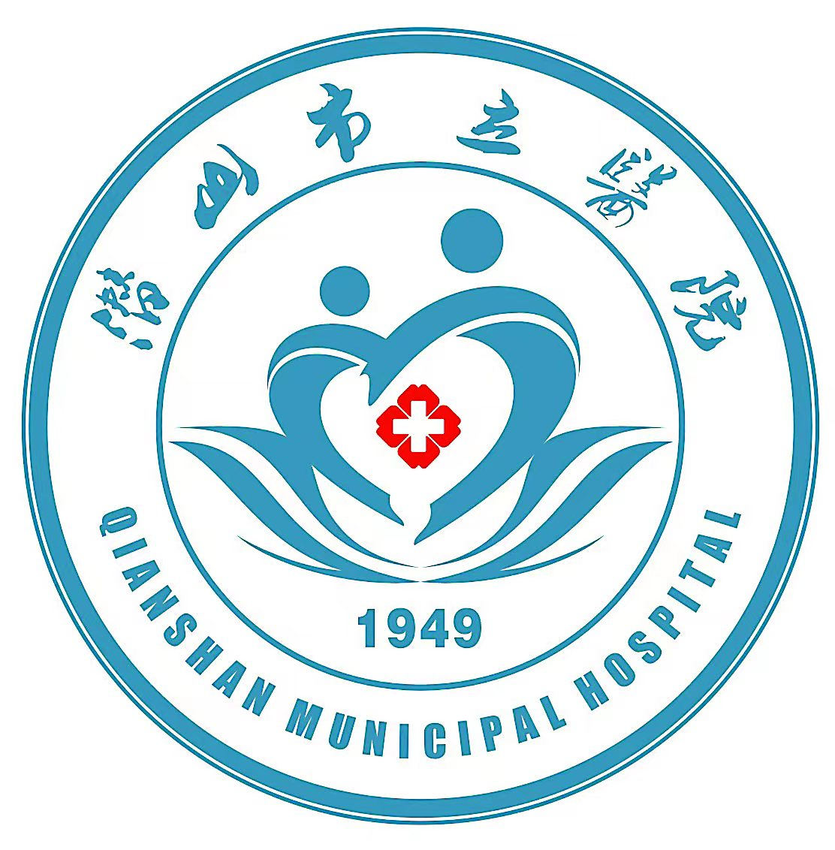

潜山市立医院各科室工作服装统计表（总表）
科室 | 男医 |  |  |  |  | 女医 |  |  |  |  | 护理 |  |  |  |  | 合计
科室 | S | M | L | XL | XXL | S | M | L | XL | XXL | S | M | L | XL | XXL | 合计
院领导 |  |  |  |  |  |  |  |  |  |  |  |  |  |  |  | 6
党委办公室 |  |  |  |  |  |  |  |  |  |  |  |  |  |  |  | 1
院办室 |  |  |  |  |  |  |  |  |  |  |  |  |  |  |  | 8
医共体办 |  |  |  |  |  |  |  |  |  |  |  |  |  |  |  | 1
基建办 |  |  |  |  |  |  |  |  |  |  |  |  |  |  |  | 1
信息科 |  |  |  |  |  |  |  |  |  |  |  |  |  |  |  | 4
人力资源科 |  |  |  |  |  |  |  |  |  |  |  |  |  |  |  | 4
监察审计科 |  |  |  |  |  |  |  |  |  |  |  |  |  |  |  | 3
保卫科 |  |  |  |  |  |  |  |  |  |  |  |  |  |  |  | 1
防保科 |  |  |  |  |  |  |  |  |  |  |  |  |  |  |  | 3
医教科 |  |  |  |  |  |  |  |  |  |  |  |  |  |  |  | 5
质控科 |  |  |  |  |  |  |  |  |  |  |  |  |  |  |  | 2
医保科 |  |  |  |  |  |  |  |  |  |  |  |  |  |  |  | 21
体检中心 |  |  |  |  |  |  |  |  |  |  |  |  |  |  |  | 5
医院感染管理科 |  |  |  |  |  |  |  |  |  |  |  |  |  |  |  | 3
护理部 |  |  |  |  |  |  |  |  |  |  |  |  |  |  |  | 3
绩效办 |  |  |  |  |  |  |  |  |  |  |  |  |  |  |  | 4
物价办 |  |  |  |  |  |  |  |  |  |  |  |  |  |  |  | 2
统计科 |  |  |  |  |  |  |  |  |  |  |  |  |  |  |  | 4
财务科 |  |  |  |  |  |  |  |  |  |  |  |  |  |  |  | 7
后勤保障科 |  |  |  |  |  |  |  |  |  |  |  |  |  |  |  | 10
设备科 |  |  |  |  |  |  |  |  |  |  |  |  |  |  |  | 7
药剂科 |  |  |  |  |  |  |  |  |  |  |  |  |  |  |  | 31
输血科 |  |  |  |  |  |  |  |  |  |  |  |  |  |  |  | 9
超声医学科 |  |  |  |  |  |  |  |  |  |  |  |  |  |  |  | 13
心电图室 |  |  |  |  |  |  |  |  |  |  |  |  |  |  |  | 3
脑电图室 |  |  |  |  |  |  |  |  |  |  |  |  |  |  |  | 3
检验科 |  |  |  |  |  |  |  |  |  |  |  |  |  |  |  | 22
血透室 |  |  |  |  |  |  |  |  |  |  |  |  |  |  |  | 3
血透室病区 |  |  |  |  |  |  |  |  |  |  |  |  |  |  |  | 10
心血管内科 |  |  |  |  |  |  |  |  |  |  |  |  |  |  |  | 8
心血管内科病区 |  |  |  |  |  |  |  |  |  |  |  |  |  |  |  | 13
骨一科 |  |  |  |  |  |  |  |  |  |  |  |  |  |  |  | 8
骨一科病区 |  |  |  |  |  |  |  |  |  |  |  |  |  |  |  | 9
骨二科 |  |  |  |  |  |  |  |  |  |  |  |  |  |  |  | 8
骨二科病区 |  |  |  |  |  |  |  |  |  |  |  |  |  |  |  | 9
急诊科 |  |  |  |  |  |  |  |  |  |  |  |  |  |  |  | 12
急诊科病区 |  |  |  |  |  |  |  |  |  |  |  |  |  |  |  | 26
中医科 |  |  |  |  |  |  |  |  |  |  |  |  |  |  |  | 5
麻醉科 |  |  |  |  |  |  |  |  |  |  |  |  |  |  |  | 10
麻醉科病区 |  |  |  |  |  |  |  |  |  |  |  |  |  |  |  | 2
ICU |  |  |  |  |  |  |  |  |  |  |  |  |  |  |  | 7
ICU病区 |  |  |  |  |  |  |  |  |  |  |  |  |  |  |  | 14
CT室 |  |  |  |  |  |  |  |  |  |  |  |  |  |  |  | 14
放射科 |  |  |  |  |  |  |  |  |  |  |  |  |  |  |  | 8
消化内科 |  |  |  |  |  |  |  |  |  |  |  |  |  |  |  | 8
消化内科病区（内镜中心） |  |  |  |  |  |  |  |  |  |  |  |  |  |  |  | 15
介入科 |  |  |  |  |  |  |  |  |  |  |  |  |  |  |  | 1
供应室 |  |  |  |  |  |  |  |  |  |  |  |  |  |  |  | 9
呼吸内科 |  |  |  |  |  |  |  |  |  |  |  |  |  |  |  | 10
呼吸内科病区 |  |  |  |  |  |  |  |  |  |  |  |  |  |  |  | 13
神经外科 |  |  |  |  |  |  |  |  |  |  |  |  |  |  |  | 7
神经外科病区 |  |  |  |  |  |  |  |  |  |  |  |  |  |  |  | 10
病理科 |  |  |  |  |  |  |  |  |  |  |  |  |  |  |  | 3
磁共振室 |  |  |  |  |  |  |  |  |  |  |  |  |  |  |  | 5
口腔科 |  |  |  |  |  |  |  |  |  |  |  |  |  |  |  | 5
泌尿外科 |  |  |  |  |  |  |  |  |  |  |  |  |  |  |  | 5
胸外科 |  |  |  |  |  |  |  |  |  |  |  |  |  |  |  | 6
泌尿外科（胸外科）病区 |  |  |  |  |  |  |  |  |  |  |  |  |  |  |  | 10
眼科 |  |  |  |  |  |  |  |  |  |  |  |  |  |  |  | 6
普通外科 |  |  |  |  |  |  |  |  |  |  |  |  |  |  |  | 10
普通外科病区 |  |  |  |  |  |  |  |  |  |  |  |  |  |  |  | 10
手术室病区 |  |  |  |  |  |  |  |  |  |  |  |  |  |  |  | 13
妇产科 |  |  |  |  |  |  |  |  |  |  |  |  |  |  |  | 11
产房病区 |  |  |  |  |  |  |  |  |  |  |  |  |  |  |  | 7
妇科（中医）病区 |  |  |  |  |  |  |  |  |  |  |  |  |  |  |  | 10
产科（眼科）病区 |  |  |  |  |  |  |  |  |  |  |  |  |  |  |  | 12
儿科 |  |  |  |  |  |  |  |  |  |  |  |  |  |  |  | 12
儿科病区 |  |  |  |  |  |  |  |  |  |  |  |  |  |  |  | 18
皮肤科 |  |  |  |  |  |  |  |  |  |  |  |  |  |  |  | 2
门诊部 |  |  |  |  |  |  |  |  |  |  |  |  |  |  |  | 8
耳鼻喉科 |  |  |  |  |  |  |  |  |  |  |  |  |  |  |  | 7
耳鼻喉科病区 |  |  |  |  |  |  |  |  |  |  |  |  |  |  |  | 13
神经内科 |  |  |  |  |  |  |  |  |  |  |  |  |  |  |  | 10
神经内科病区 |  |  |  |  |  |  |  |  |  |  |  |  |  |  |  | 14
感染科 |  |  |  |  |  |  |  |  |  |  |  |  |  |  |  | 8
感染科病区 |  |  |  |  |  |  |  |  |  |  |  |  |  |  |  | 8
康复科 |  |  |  |  |  |  |  |  |  |  |  |  |  |  |  | 19
康复科病区 |  |  |  |  |  |  |  |  |  |  |  |  |  |  |  | 9
肿瘤科 |  |  |  |  |  |  |  |  |  |  |  |  |  |  |  | 9
肿瘤科病区 |  |  |  |  |  |  |  |  |  |  |  |  |  |  |  | 12
发热门诊 |  |  |  |  |  |  |  |  |  |  |  |  |  |  |  | 5
轮转医生 |  |  |  |  |  |  |  |  |  |  |  |  |  |  |  | 31
轮转护理 |  |  |  |  |  |  |  |  |  |  |  |  |  |  |  | 27
疫苗接种点 |  |  |  |  |  |  |  |  |  |  |  |  |  |  |  | 6
核酸检测点 |  |  |  |  |  |  |  |  |  |  |  |  |  |  |  | 6
预检分诊 |  |  |  |  |  |  |  |  |  |  |  |  |  |  |  | 3
预留 |  |  |  |  |  |  |  |  |  |  |  |  |  |  |  | 200
 | 965
医院院徽

